Analysis of Boston Data
What factors effect the price in house?
- Select data points with high correlation to the target value
- Be leery of collinearity
Based off the heatmap, the following are relevant attributes of data
- LSTAT (% lower status of the population) with .74 correlation
- RM (average rooms per house) with .7 correlation
- Correlation between the two are .64, so safe to use these inputs
- Both look like a linear relationship after visualizing the data
Evaluation of model
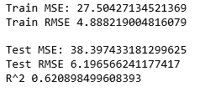
- F-stat of 1112, so confirmation that at least one of the variables is significant
- Linear equation: y = -.672 + 4.873(RM) - .585(LSTAT)
Tuning Model
- I want to add complexity to the model by adding in the next term with the highest correlation
- This term is called PTRATIO, or the pupil teacher ratio by town, with a -.51 correlation
  - Scatterplot seems linear

Evaluation of Model
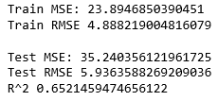
- Train and test error decreases, so the addition of PTRATIO improved the model
More tuning
- I will continue to add complexity by adding another parameter
- INDUS, or proportion of non-retail business acres per town has the next highest correlation at -.48
Evaluation of model
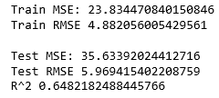
- Test error increases while train error decreases; adding this data overfits the model
Conclusion
The best model included 3 parameters, LSTAT, RM, and PTRATIO. The addition of INDUS overfit the model and should be taken out of the model.

